The University of Montevallo
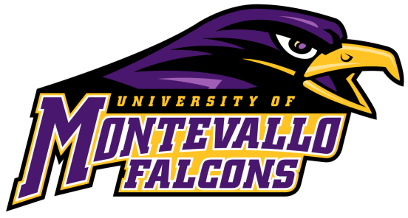
is a public liberal arts university located in central Alabama (35 miles from Birmingham) offering a life-enriching honors educational experience stressing community service and global awareness, all within an atmosphere of natural historic beauty. There is much enthusiasm with the
recent addition of new academic programs,
intercollegiate sports, and classroom facilities.

MONTEVALLO AT A GLANCE

- Student enrollment averages 2,700 per year
- Average class size at UM is 23
- Our beautiful 160 acre campus is listed on the National Register of Historic Places
- 95% of Montevallo faculty hold the terminal degree in their discipline
- Abundant opportunities for experiential learning include internships, study abroad, student research, service learning, and community partnerships
- Over 90 student organizations make it easy to get involved in campus life

The University of Montevallo offers over 75 major/concentration combinations within four colleges. Newer programs of study include:
- Major and Minor in Computer Science
- Major in Early Childhood Education
- Minor in Social Media Administration
- Minor in Cybersecurity
- Concentration in Criminology

Recent UM Announcements and Accolades:
- The Center for the Arts opened in Fall 2020 providing state-of-the-art classrooms, theaters, labs, studios and student art gallery
- Top 20 Most Innovative Schools --- Top 20 Best Value Schools --- Top 20 Best Undergraduate Teaching --- Top 15 Best Public Regional Universities in the South
(US News and World Report Best Colleges)
- Top 10% of U.S. universities for providing financial assistance to freshmen (The Student Loan Report.)
- Top 5% in the U.S. for lowest student loan debt (The Student Loan Report)
- Most beautiful public college campuses in America (Thrillist.com)

Scholarship Information:
- Out-of-state students awarded any UM-funded scholarship will also receive the Out-of-State Scholarship and would be assessed in-state tuition rates
- Montevallo will superscore for merit-based scholarships

For more information go to www.montevallo.edu or contact
Randy Engle (engler@montevallo.edu) at 205-900-3422

